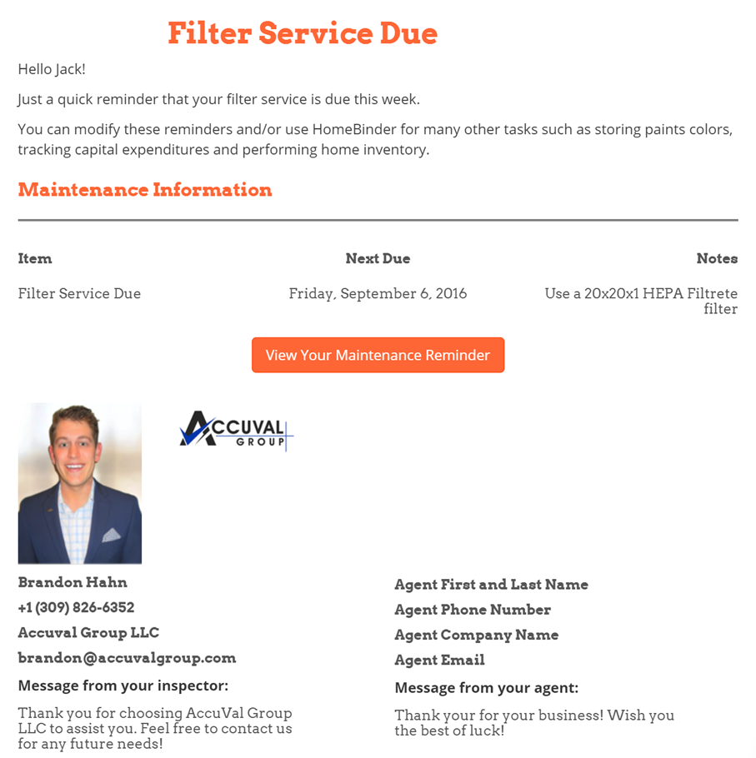
SAMPLE MAINTENANCE E-MAIL

REALATOR LOGO
HEADSHOT

